**Model Pipeline**

Pipeline is a tool that simplifies and automates the process of building a machine learning workflow.

* It allows for the **sequential execution of multiple steps**, combining **data preprocessing** and the **final model training or prediction** into a single and streamlined process.
* Sequential chain of **transformers** (e.g., preprocessors like scaling, encoding, or feature extraction) followed by an **estimator** (e.g., a classifier or regressor) 🡺 ensures that the entire workflow is applied consistently and efficiently.
* Each step in the pipeline performs its transformation and passes the output to the next step.
  + **Transformers**:
    - Apply ***.fit_transform()*** during **training** and ***.transform()*** during **testing**.
  + **Estimator**:
    - Applies ***.fit()*** during **training** and ***.predict()*** during **testing**.
* **Workflow**

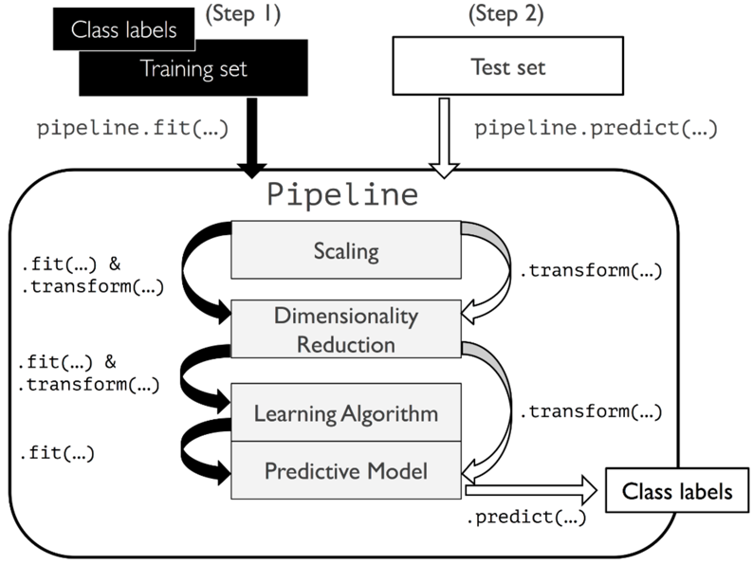

Binary classification with numeric features

* The goal is to predict the binary classification with building the pipeline.

**Components of a pipeline**

1. **Steps**:

* Each step is a tuple of a name and an object (transformer or estimator) 🡺 ('scaler', StandardScaler()).

1. **Preprocessing**:

* Steps like scaling, encoding, or imputing missing values.
* Must implement ***.fit()*** and ***.transform()*** methods.

1. **Estimator**:

* The final step of the pipeline is the machine learning model.
* Must implement ***.fit()*** and ***.predict()*** methods.

1. Hyperparameter tuning with pipeline

* Use “_ _” for each specific model for the hyperparameter tuning.
* Apply pipeline with dictionary of the hyperparameters using ***.fit(X_train, y_train)***

**Workflow of pipeline in binary task using *Pipeline([ ])***

* **'scale'**: Applies StandardScaler to standardize the features by removing the mean and scaling to unit variance.
* **'pca'**: Uses PCAto reduce the dimensionality of the dataset to 15 components.
* **'lr'**: Fits a LogisticRegression model as the final estimator.
* Using ***.fit(train, test)*** to get the sense of the model prediction by log reg.

* Use log reg model performance from pipeline (pipe1) to extract the PCs coefficients

* Use PCA model from pipeline (pipe1) to get each PCs

**Hyperparameter tuning via Pipeline**

* We need to specify the hyperparameter’s name with its corresponding model names with **“_ _”**
* Fit the pipeline (pipe1) with the specified hyperparameters to fit the X_train and y_train.
* Apply ***.score(X_train, y_train)*** to get the result.

**Pipeline display**

* By fitting the training data from the pipeline construction, we can visualize how each parameter inside the pipeline’s content and the workflow
* Order of each of the parameter inside the pipeline matters.

* Display the best estimator of each model inside the pipeline using ***.best_estimator_***

**Column Transformer**

It allows you to apply different transformations to different subsets of columns, which is particularly useful when dealing with datasets that have mixed data types, such as categorical and numerical features.

Column Transformer components

* Selective Transformation:
  + Apply specific preprocessing steps to **specific columns**.
* Integration with Pipelines:
  + Can be **used as part of a scikit-learn pipeline**.
* Support for Mixed Data Types:
  + Handle **numeric and categorical** data differently.

Workflow of column transformer with pipeline

1. Apply data column with **numerical features** processing with specific columns

* + Fill the missing value for columns age and fare with median with ‘imputer’
  + Standardize both columns with standard scaler with ‘scaler’

1. Apply another different column with **categorical features** with different processing method

* + Use simple imputing and one-hot encoding to process specified columns with ‘imputer’ and ‘onehot’

1. Combine both processing column transformer pipeline as preprocessor.

* + Combine the preprocessing with ColumTransformer

1. Set the final pipeline with the model training

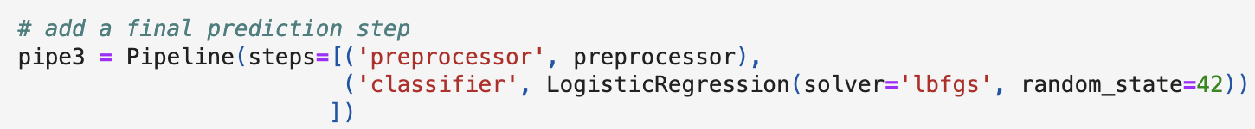

1. Visualization of pipeline

1. Apply the data splitting for model performance

* + We can use ‘survived’ as the binary target and all other features as the IVs
  + Apply train_test_split to split the data with X and y for model training

1. Connect with previous column transformation pipeline with split data using ***pipeline.fit (X, y)***

* + With pipe3, we conducted all the column transformation with numerical and categorical feature transformation and apply to the splitted train and test dataset.

1. Hyperparameter tuning with pipeline

* + We integrated the defined parameter for imputer and hyperparameter for classifier.
  + Use Grid Search to incorporate pipeline and set of hyperparameter with 3-fold CV.
  + After we impute the data by column transformation and hyperparameter tuning, we fit the training data with the integrated pipeline and obtain the best score for test set with 75.2%

1. Visualize the holistic pipeline structure

**NLP**

NLP terms with example (a corpus with 2 sentences)

**“I love NLP.”**

**“NLP is fun and interesting!”**

1. **Token (Smallest Unit**):

* A token is a single word or part of word extracted after splitting the text.
* ["I", "love", “NLP”, “.”] or [“I”, “l”, “o”, “v”, “e”, “,” …]

1. **String (Sequence of characters):**

* A string is a list of characters representing raw text.
* "I love NLP." Or ‘I love’

1. **Document (Unit of cohesive text)**

* A document is a cohesive unit of text that can consist of one or more strings.
* “I love NLP." Or ‘I love’

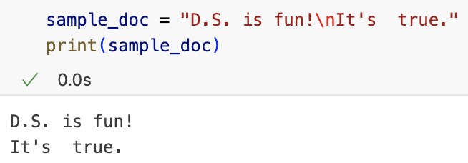

1. **Corpus (Collection of documents)**

* A corpus is a collection of multiple documents.
* ["I love NLP.", "NLP is fun and interesting!"]

1. **Vocabulary (Largest Representation):**

* The vocabulary is the set of unique tokens found in the entire corpus.
* Unique words, punctuation, and case-sensitive in this example
* {"I", "love", "NLP", ".", "is", "fun", "and", "interesting", “!”}

**Regular Expression Query**

Define search pattern in the text in Regular expression by string

* Use all lib ‘re’ for executing query

1. To find all of the whitespaces in doc by “\s+”

1. To find any single character except newline (r'.' matches 'x')
2. To match 0 or more repetitions (r'x*' matches 'x','xx','')
3. To match 1 or more repetitions (r'x+' matches 'x','xx')
4. To match 0 or 1 repetitions (r'x?' matches 'x' or '')
5. `^`: beginning of string (r'^D' matches 'D.S.')
6. `$`: end of string (r'fun!$' matches 'DS is fun!'`)

**Tokenization**

A process of breaking a document into a list smaller unit (tokens) to prepare text for further analysis by *converting unstructured data (raw text) into structured tokens*.

* **Goal**: we need to convert each token into feature vector for later model performance after we have tokenized raw data into a simpler form to reduce redundancy.
* **Token**: The individual elements resulting from tokenization. These can be words, punctuation marks, or subwords, depending on the tokenizer.
  + Document: "The cat sits on the mat."
  + Tokens: ["The", "cat", "sits", "on", "the", "mat", "."]
* **Vocabulary**:
  + The set of unique tokens in a corpus. It represents the complete list of words or symbols used across all documents.

Ways of splitting document into tokens

1. Split on whitespace with ***re.split(r ‘reg expression’, document )***

1. Find all the regular expression query using ***re.findall(r ‘reg expression’, document )***

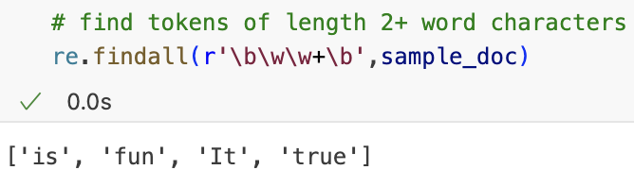

**NLP Preprocessing**

We can process the text sentences from raw data into structured for later analysis

1. Convert the text into lower-cased sentence using ***text.lower()***

1. Remove special characters in the raw data including punctuation using regular expression query.

1. Lemmatization: Reduce words to their base (lemma) form to standardize variations.

* Use WordNetLemmatizer

* Initialize lemmatizer

* Tokenize the text into each token by splitting



* Apply lemmatization to each token



* + Studies 🡺 Study
  + Studying 🡺 Study
* Join lemmatized tokens into a string

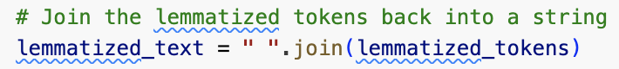

**Bag of Words (BoW)**

It converts a document or corpus into a collection of tokens, ignoring grammar and word order, while keeping track of the frequency of each word.

1. **Word Order Ignored**:

* BoW treats the document as a “bag” of words, disregarding their sequence.
  + "NLP is fun" and "fun is NLP" have the same BoW representation.

1. **Frequency-Based Representation**:

* The model counts the occurrence of each word in the document.

1. **Vocabulary**:

* The unique words across the entire corpus form the vocabulary.
* The size of the vocabulary determines the dimensions of the BoW representation.

**n-Grams**

An n-gram is a contiguous sequence of n tokens (words or characters) from a given text.

**Types of n-Grams**

1. Unigram:

* Consists of single tokens.
  + "I love NLP" → ["I", "love", "NLP"]

1. Bigram:

* Consists of two consecutive tokens.
  + "I love NLP" → ["I love", "love NLP"]

1. Trigram:

* Consists of three consecutive tokens.
  + "I love NLP" → ["I love NLP"]

1. n-Gram:

* General case where n can be any positive integer
  + For n=4: "I love NLP tools" → ["I love NLP tools"]

**Initialize the n-grams**

* Tokenize the document using ***.split()***

* Choose unigram

* Choose bigram

Every time it moves to the next gram, it maintain the **same size of the n-gram but move by 1 step** until the token reaches to the end.

**TF (Term Frequency) and DF (Document Frequency)**

TF and DF are statistical measures that describe the importance of words in a document or corpus.

Example corpus: 2 documents in one corpus

* TF: the # of times a specific term is seen per document 🡺 The # of times a **term t** appears in a **document d** in the corpus.

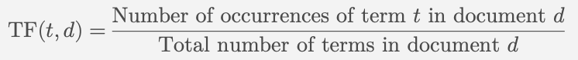

* + Count the # of vocabs in each document

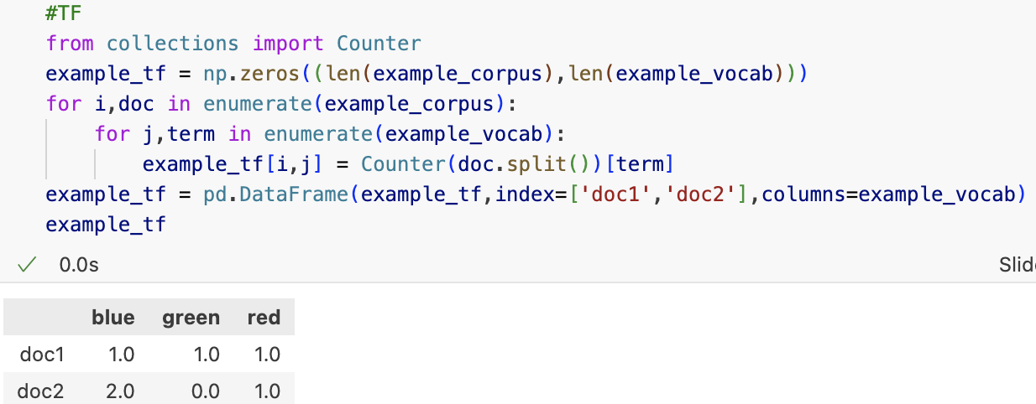

* DF: The # of different **documents** containing the same **term t** in the corpus.



* + Count # of document with particular token in the corpus

**Motivation of TF**

* Common words like “the,” “is,” and “and” will have high frequencies, even though they provide little meaning.

**Motivation of DF:**

* It doesn’t consider how frequently the term appears in individual documents.
* Once we know how those terms without significant meaning, we can use DF to see how often they appear in each document.

**Stopwords**

* Stopwords are common words that carry little meaningful information in text analysis. These words often appear frequently across many documents, *such as “the,” “a,” “in”*.
* We tend to remove the stopwords since it will **lead high DF while containing no unique meaning and little understanding of context**.

**Remove stopwords using *.CountVectorizer(stop_words = English)***

1. Use count vectorizer to **convert text data into a numerical representation** using the **BoW** model.

* + - lowercase = True 🡺 Convert text to lowercase (default)

* + - ngram_range = (1,1) 🡺 Extract unigrams (individual words)

* + - min_df = 1 🡺 Include words appearing in at least 1 document
    - max_df=1.0 🡺 Include words appearing in at most 100% of documents

1. get the vocabulary from the corpus

1. get the corresponding feature names regard to feature index

1. get term frequencies

1. transfer the term frequency into the vocab mapping

**Combining TF and DF:**

* TF-IDF helps normalize the importance of terms by considering both term frequency and document rarity.

**TF-IDF (Term Frequency-Inverse Document Frequency)**

TF-IDF is a statistical measure to evaluate the importance of a term in a document relative to a corpus. It helps identify terms that are informative by balancing term frequency (TF) and document frequency (DF). The goal is to **downweigh common terms that appear across many documents**, reducing their influence on the final text representation.

**Purpose of TF-IDF**

* Problem with Term Frequency (TF): Common words like “the,” “is,” and “and” appear frequently but don’t provide much information.
* Solution: Use **Inverse Document Frequency (IDF) to reduce the weight of frequent terms and highlight important ones**.

**TF-IDF function components**

1. **Term Frequency (TF):** How often a term t appears in document d.

1. **Inverse Document Frequency (IDF):** A measure that decreases the importance of terms appearing in many documents.

* + N: total # of document
  + DF(t): # of document containing term t.

1. TF-IDF weight



Coding technique

* Initialize TF-IDF vectorizer

* + Fit and transform the corpus with TF-IDF
  + Convert the input corpus with vocabs by default index.
* Calculate TF-IDF for each term frequency in 2 documents

* + We can consider each document with feature importance by magnitude of TF-IDF relative to the whole corpus.
* Compare with the original term frequency

**Topic Modeling**

Topic Modeling is an **unsupervised learning** technique used to discover hidden topics in a collection of documents.

* It assumes that
  + ***Documents are composed of topics.***
  + ***Topics are collections of related terms.***
* Given the collection of documents
  + **Topic**:
    - ***A collection of terms that frequently appear together that define a topic***
    - ["data", "model", "analysis", "algorithm"]
  + **Term Distribution (Per Topic):**
    - ***What terms make up each topic?***
    - Topic 1 might include terms like {"data": 0.3, "model": 0.25, "analysis": 0.15}.
  + **Topic Distribution (Per Document):**
    - ***What topics make up each document?***
    - Document A might be {"Topic 1": 70%, "Topic 2": 30%}.
* This helps summarize, organize, and explore large datasets of text by automatically grouping terms into topics.

**Motivation**

1. **Understand Large Text Collections**: Extract topics from thousands of documents quickly.
2. **Dimensionality Reduction**: Represent documents using topic weights instead of individual terms.
3. **Text Summarization**: Extract key ideas from lengthy texts.
4. **Document Classification & Clustering**: Group similar documents into clusters based on shared topics.

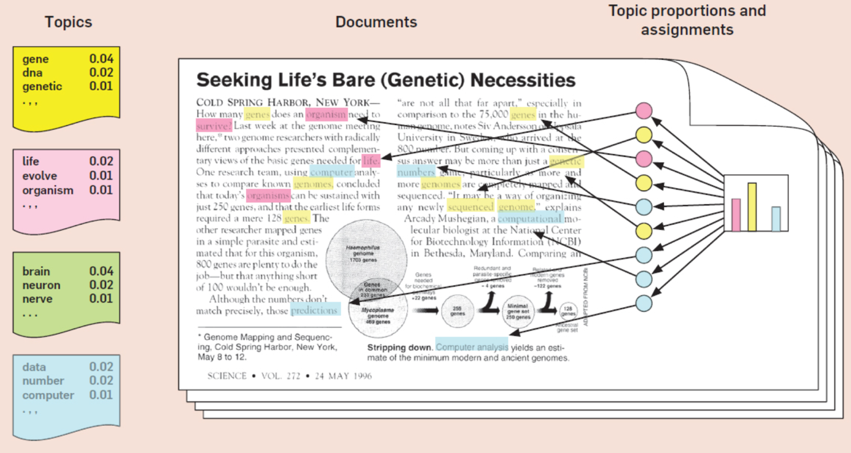

**Latent Dirichlet Allocation (LDA)**

Assumes documents are mixtures of topics, and each topic is a mixture of terms, and the **distributions in topic modeling** are determined **based on term frequency patterns**.

* 2 important matrices learned by LDA

1. **Per topic term distribution (phi)**

* + Phi describes how each term distributed in each topic

1. **Per document topic distribution (theta)**

* + Theta indicates how each topic distributed in each document.

**Example of topic modeling in code**

1. Construct a topic, document, and vocab in the predefined corpus.

* + We need to define the metrics for later LDA modeling

1. Per topic term distribution given documents and vocab

1. Per document topic distribution

**Purpose of LDA**

* **To predict the topics of documents based on their content** by identifying latent topics in a collection of documents.
* LDA assumes that documents are mixtures of topics, and each topic is a collection of related words.

**How LDA Works**

1. Input: A collection of documents (text data).
   * A set of documents
   * A number of topics K
2. Process:
   * LDA models each document as a distribution of topics (Theta): M * K
   * Each topic is a distribution of words (Phi): K * V
3. Output:
   * **Per-topic term distribution**: What words belong to each topic.
   * **Per-document topic distribution**: What topics describe each document.

LDA Example with Python

1. Define a corpus with libs

1. Create count vectorizer by removing stop words

1. Initialize LDA with 2 topics

* + n_components = 2 indicate we will generate 2 topics from the vectorized corpus.

1. We need to display the topics consisted of top terms based on the LDA

* + Based on each term for topic, we can come up with the general topic name specifically.